Six Weeks Industrial Training Project Report

On

**CINEPOLIS**

Submitted in the Partial fulfillment of the requirement for the Award of Degree of

**Bachelor of Technology**

In

**COMPUTER SCIENCE &ENGINEERING**

Batch

(2014-18)



|  |  |
| --- | --- |
| **Submitted to**  Department of CSE | **Submitted by**  Nagesh(1400402)  Paramjit Kaur(1400413) |
|  |  |

**DEPARTMENT OF COMPUTER SCIENCE & ENGINEERING**

**Amritsar College of Engineering & Technology, Amritsar**

**DECLARATION**

We swear that the project work submitted by us, entitled “Cinepolis”. In MYSQL and PHP form the partial fulfillment of the award of 6 week industrial training of Computer Science Engineering to Amritsar College Of Engineering and Technology,Manawala (Amritsar) is an authentic record of an own work carried out by us in THE SECOND YEAR OF degree in the period (2014-2018) under guidance of Er. Girish Kumar,Professor at Amritsar College Of Engineering and Technology Manawala,( AMRITSAR).

We or anybody else for the award of any other degree has not

Submitted the matter embodied in this dissertation.

Nagesh(1400402)

Paramjit Kaur(1400413)

Above statements by the candidates are true to the best of our knowledge.

Supervisor:

Er. Girish Kumar

**ACKNOWLEDGEMENT**

This is our humble effort to express our sincere thanks to various people to help us in achieving the target of this project. We have been able to learn many valuable aspects of this vast computer field. Many people have rented us their precious time, valuable suggestions which provided to be stepping for the completion of the project. We would sincerely like to acknowledge with deep sense of gratitude for their help.

First and foremost, we are thankful to god for enabling us to develop this project. Without his connect this project would not have scene light of the day.

Secondly, we are highly indebted to Dr.VK Banga (Principal) of Amritsar College Of Engineering and Technology,Manawala, (Amritsar) and Girish Kumar(Professor) of provided valuable suggestions, guidance, untiring help, utmost interest and encouragement for the completion of the project.

Last but not least we find no words to acknowledge financial assistance and moral support ranted by our parents in making the effort of a success. Without their help it would have been extremely difficult for us to prepare this project.

**CERTIFICATE**

This is to certify that this project entitled ”Cinepolis” submitted for COMPELETION of Requirements of 6 week industrial training of Computer Science , Amritsar College Of Engineering and Technology is bonafide piece of project work carried out by us under our guidance and supervision.

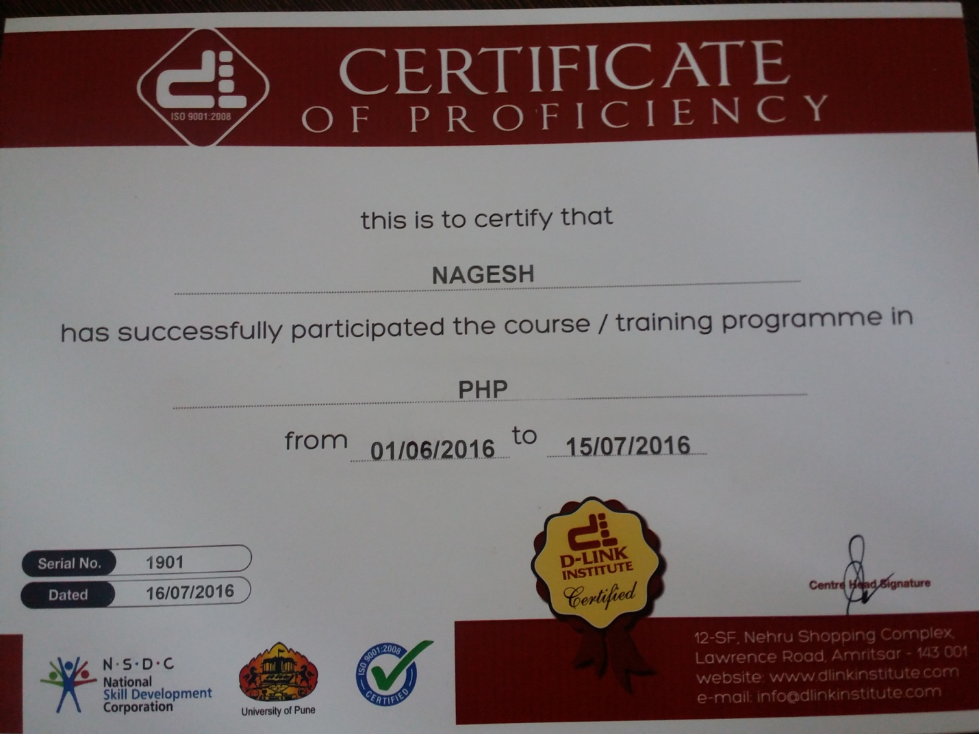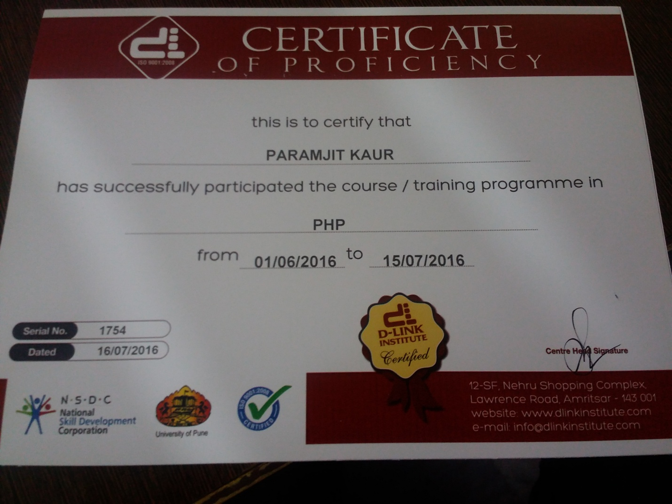

SUPERVISOR

Er. Girish Kumar

(Professor acet)

Harman Sir

(D-Link Institute)

**D Link Institute**

**About us**

As Mark Twain said,” There is nothing training cannot do. Nothing is above its reach. It can turn bad morals to good, it can destroy bad principles and recreate good ones, it can lift men to angel ship”. We, at D-Link truly believe this thought and train our disciples for growth in their knowledge and skill to become better professionals.

Today when we talk about the field of IT education the name which strikes us all is **D-Link Institute**. We started from one room in year 2009 and our hard work has enabled to shift to a bigger and better facility with multiple training rooms as per requirement of the subject.

Entering seventh year of existence, D-Link Institute has established itself as a major brand in imparting Industrial Training in the field of IT. Any education is incomplete without practical training. Practical Training is link between a student and a professional. It is a link between books and tools. And it is a link between a college and a job. Here, we strive to bridge this gap and create a **Direct Link** for our student.

Our students stand as our brand-ambassadors and their final placement in reputed corporate encourages us to deliver better than every passing day. We provide 100% placement assistance to our students by arranging in-house Placement Services by arranging Job fairs.

We endeavor to assist our students to prepare for all rounds of placement process. We strive to imbibe overall confidence in our pupil so that he can strike the right cord during his interview and further in his career. At D-Link we believe that our student should develop as a better and confident professional. Hence our students get end-to-end services starting from training to final job placement.

**What do we Offer?**

D Link institute is centrally located in the business hub of the holy city at Nehru complex and is visioned to offer a variety of courses as Asp.Net, VB.Net, Java, PHP, Oracle, Embedded Systems, Networking, Auto-Cad, Pro-E,CATIA & STADD-Pro for students of IT, Electronics & Communication, Mechanical & Civil Department.

The success of this institute can be judged by the number of students who have undergone the training - more than 15000 students have been benefited from our endeavor.

**USP of the Institute**

The strength of this organization lies in dedication of its team towards work and vision of its leader.  Following this principle, D-Link Institute constitutes a team of IT Engineers who regularly upgrade themselves to match Global Standards in terms of course content & curriculum. This enables students to match their pace with this ever developing world of Information Technology. This factor has benefited the students by boosting their confidence achieved by knowledge of latest skills.

**Our Success Story**

D Link Institute has trained more than 15000 students (now professionals) as part of their curriculum in their regular studies. This training has provided a stepping stone to their aspiring careers.

**A Few Highlights**

D Link Institute is equipped with State of the art computer labs, which are regularly upgraded with change in technology. Use of licensed software’s and courseware’s providing optimum use of the resources.

We emphasis on Practical Training where students are given end user tasks and projects that help them understand exact market scenario. Industrial seminars are organized to enhance students’ skills. Career counseling sessions and job fairs, on periodic basis, further fortify our wholesome approach.

D Link Institute has also ventured into providing Web based Solutions under name and style of Soft Built Solutions which provide services such as:

* Website-Designing
* Website-Development
* E-commerce Solutions
* Android App Development
* Big-Data & SAS.
* Search Engine Optimization
* Corporate Office Setups
* VSAT Communication
* Training on Software’s like MATLAB, NS2, HFSS, PLC SKADA

 Soft Built Solutions has served more than 1000+ satisfied clients, globally and the number is growing consistently.

**Bite**: Utmost care is taken in designing the training module. We, at D Link Institute, believe that the most important thing for any student is to understand basic concepts with in-depth clarity. A student with clear basics can face any difficult situation with ease. Also it acts as the most essential factor for a students’ selection in corporate sector.

**INDEX**

|  |  |  |
| --- | --- | --- |
| **SR.NO.** | **CONTENTS** | **PG NO.** |
| 1. | INTRODUCTION TO PROJECT | -9 |
| 2. | SYSTEM REQUIREMENTS | 10 |
| 3. | FRONTEND & BACKEND | 11-15 |
| 4. | SYSTEM ANALYSIS | 16-17 |
| 5. | FEASIBILITY STUDY | 17-20 |
| 6. | EXISTING SYSTEM | 20 |
| 7. | PROPOSED SYSTEM | 21 |
| 8. | SYSTEM DEVELOPMENT LIFE CYCLE | 22-23 |
| 10. | FEASIBILITY STUDY | 24-26 |
| 11. | SYSTEM DESIGN | 26-28 |
| 12. | SNAPSHOTS | 29-43 |
| 13. | TABLES | 44-53 |
| 14. | CONCLUSION | 54 |
| 15. | SCOPE AND FUTURE REFERENCE OF PROJECT | 55 |
| 16. | BIBLOGRAPHY | 56 |

**INTRODUCTION TO PROJECT**

**1.1 Introduction**

This purpose of the project is to produce an online ticket ordering system. This document reports the design, implementation and testing of the system. This is a online web site on which user as well as theatre owner register themselves and use this site to update movies in theatre and book tickets for particular movie. Also theatre authority can check by ticket number for valid user.The project will concentrate on ensuring the web site is secure from the varying type of attack that hackers can use, including:

• SQL injection

• Cross Site Scripting

• Session Hijacking

The website will allows be design with accessibility in mind. Existing ticket sales websites will researched to ensure that the site has a fighting chance of competition with them. The report will look at the look at important parts of code and problems during the project and how those problems were overcome. The documentation will cover the testing of the project once the implementation stage of the project is over.

**1.2 Features Of Project:**

* **Company database**: It maintains companies database which helps to know about the details of its customers.
* **Customer database**: It maintains a large database of customers (connection holders) where in all the information of customers including the personal records ,contact record, and information about how many tickets are booked by the customer. The software retrieves this data and displays as per the user requirement.
* **Searching techniques**: It provides a wide range of searching techniques.
* **Report generation**: Admin and customer can generate automatic reports according to their requirements as per the tickets booked, amount of transaction carried out.
* **Flexibility**: It also allows a Data Base Administrator to maintain the number of halls, seats in each hall and accordingly assign movies to the hall, issue coupon cods to customers which is then stored in the corresponding tables in the main database .He can also empty the hall in accordance with particular situation.
* **Cost-effective**: Helps to reduce the time and cost. Customer can get the updates directly into his account. He/she can book the ticket online while sitting at home or anywhere. Thus it reduces the cost and time as well.

|  |
| --- |
|  |

* **Reliable:** Online booking of tickets facilitates faster, unbiased, accurate and reliable processing of applications from various applications.
* One can apply various conditions and filter the output according to ones requirement.
* Online ticket booking system helps to communicate and create healthy relationships with the customers by providing various facilities.

**1.3 Features Desired:**

The featured proposed for this solution are as follows:

**Administration Section** will be overall controller and has the highest hierarchy. He will be managing the halls, number and type of seats in each hall, assigning movies to hall This section will ensure smooth functionality, maintenance, conflict resolution; recommendations, suggestions etc. come under this section.

**Customer Section** will consist of the registered users who will be performing the transactions. A user can login to his account and see the various details of his accounts as available. He can get the updates and the new incentives available in the system and take advantage. He can also view the complete history of the tickets booked so far in fun cinemas.

**Payment Process**- customer can make payment by using either of three options-

1. He can book ticket by making **cash payment** on counter before movie. By providing details as required by the website.
2. One can book his ticket by making **payment through card**.
3. At last one can also book free tickets by **redeeming points** using the issued coupon code

**1.4 Aims and objectives**

The main purpose of our online ticket booking system is to provide an alternate and convenient way for a customer to buy cinema tickets. It is an automatic system. After the data has been fed into the database, the staff does not need to do anything with the order once it is received through the system. In fact, there is similar system on the internet, but there is no refund method found in the existing system. The goals of our system are:

* To provide a anytime anyplace service for the customer
* To minimize the number of staff at the ticket box
* To promote the film on the internet
* To increase the profit
* To obtain statistic information from the booking record.

**1.5 About this project**

Our online E-Ticket System (ETS) is a web-based system. The customers can buy ticket online and cancel the seat at a suitable time To enhance the refund function, all the customers have to registration become a member before buying ticket.Staff can use the system to insert and delete data (e.g. film description , time table) which will update the webpage(webpage are dynamic page, changing according to the data in database). Also, staff can check the statistic information from the system.

**1.6 General Requirements (functional)**

1. The web page (e.g. The time table page, the main page) will be generated automatically according to the data in database.

2. A way in which the customer can create its own account(member registration).

3. A way in which the users (both customer and staff) can login to the system to perform different operation.

4. A way in which the customer can modify its own data.

5. A way in which the customer can place a order by just clicking the seat (which is shown on the screen) and insert some card data.(some simple operation).

6. A way in which the customer can check the ticket record according to the transaction number.

7. A way in which the staff can use the system to add data(e.g. film description) to the database.

8. The system can verify the data before transaction.

9. The system can generate some statistic information according booking and ticket selling record.

10. Users can check film data by clicking on a certain film on main page(e.g. The cinema which will show this films).

11. Users can check a cinema data by clicking on a certain cinema on main page(e.g. which film is now showing)

**SYSTEM REQUIREMENT**:

**HARDWARE REQUIREMENTS:**

This system must have the following Minimum Hardware Requirements:

* Processors
* 256 MB of RAM
* 5 GB of Hard Disk
* Client Machine

**SOFTWARE REQUIREMENTS:**

The system must have the following Software Requirements:

* WAMP SERVER:5.4
* GOOGLE CHROME
* MYSQL:2.4

**INTRODUCTION TO PHP**

**FRONT END**

PHP is a [server-side scripting](http://en.wikipedia.org/wiki/Server-side_scripting) language designed for [web development](http://en.wikipedia.org/wiki/Web_development) but also used as a [general-purpose programming language](http://en.wikipedia.org/wiki/General-purpose_programming_language). PHP is now installed on more than 244 million [websites](http://en.wikipedia.org/wiki/Website) and 2.1 million [web servers](http://en.wikipedia.org/wiki/Web_server). Originally created by [RasmusLerdorf](http://en.wikipedia.org/wiki/Rasmus_Lerdorf) in 1995, the [reference implementation](http://en.wikipedia.org/wiki/Reference_implementation) of PHP is now produced by The PHP Group. While PHP originally stood for Personal Home Page, it now stands for PHP: Hypertext Preprocessor, a [recursive acronym](http://en.wikipedia.org/wiki/Recursive_acronym).

PHP code is [interpreted](http://en.wikipedia.org/wiki/Interpreter_(computing)) by a web server with a PHP processor module, which generates the resulting web page: PHP commands can be embedded directly into an [HTML](http://en.wikipedia.org/wiki/HTML) source document rather than calling an external file to process data. It has also evolved to include a [command-line interface](http://en.wikipedia.org/wiki/Command-line_interface) capability and can be used in [standalone](http://en.wikipedia.org/wiki/Computer_software) [graphical applications](http://en.wikipedia.org/wiki/Graphical_user_interface).

PHP is [free software](http://en.wikipedia.org/wiki/Free_software) released under the [PHP License](http://en.wikipedia.org/wiki/PHP_License), which is incompatible with the [GNU General Public License](http://en.wikipedia.org/wiki/GNU_General_Public_License) (GPL) due to restrictions on the usage of the term PHP. PHP can be deployed on most web servers and also as a standalone [shell](http://en.wikipedia.org/wiki/Shell_(computing)) on almost every [operating system](http://en.wikipedia.org/wiki/Operating_system) and [platform](http://en.wikipedia.org/wiki/Computing_platform), free of charge.

PHP development began in 1994 when the developer [RasmusLerdorf](http://en.wikipedia.org/wiki/Rasmus_Lerdorf) wrote a series of [Common Gateway Interface](http://en.wikipedia.org/wiki/Common_Gateway_Interface) (CGI) [Perl](http://en.wikipedia.org/wiki/Perl) scripts, which he used to maintain his [personal homepage](http://en.wikipedia.org/wiki/Personal_homepage). The tools performed tasks such as displaying his résumé and recording his [web traffic](http://en.wikipedia.org/wiki/Web_traffic). He rewrote these scripts in [C](http://en.wikipedia.org/wiki/C_(programming_language)) for performance reasons, extending them to add the ability to work with [web forms](http://en.wikipedia.org/wiki/Web_form) and to communicate with [databases](http://en.wikipedia.org/wiki/Database), and called this implementation "Personal Home Page/Forms Interpreter" or PHP/FI. PHP/FI could be used to build simple, dynamic [web applications](http://en.wikipedia.org/wiki/Web_application). Lerdorf initially announced the release of PHP/FI as "Personal Home Page Tools (PHP Tools) version 1.0" publicly to accelerate [bug](http://en.wikipedia.org/wiki/Software_bug) location and improve the code, on thecomp.infosystems.www.authoring.cgi [Usenet](http://en.wikipedia.org/wiki/Usenet) discussion group on June 8, 1995. This release already had the basic functionality that PHP has as of 2013. This included Perl-like variables, form handling, and the ability to embed HTML. The [syntax](http://en.wikipedia.org/wiki/Syntax) resembled that of Perl but was simpler, more limited and less consistent. A development team began to form and, after months of work and [beta](http://en.wikipedia.org/wiki/Development_stage#Beta) testing, officially released PHP/FI 2 in November 1997.

[ZeevSuraski](http://en.wikipedia.org/wiki/Zeev_Suraski) and [AndiGutmans](http://en.wikipedia.org/wiki/Andi_Gutmans) rewrote the [parser](http://en.wikipedia.org/wiki/Parser) in 1997 and formed the base of PHP 3, changing the language's name to the [recursive acronym](http://en.wikipedia.org/wiki/Recursive_acronym)PHP: Hypertext Preprocessor. Afterward, public testing of PHP 3 began, and the official launch came in June 1998. Suraski and Gutmans then started a new [rewrite](http://en.wikipedia.org/wiki/Rewrite_(programming)) of PHP's core, producing the [Zend Engine](http://en.wikipedia.org/wiki/Zend_Engine) in 1999. They also founded [Zend Technologies](http://en.wikipedia.org/wiki/Zend_Technologies) in [Ramat Gan](http://en.wikipedia.org/wiki/Ramat_Gan), Israel.

On May 22, 2000, PHP 4, powered by the Zend Engine 1.0, was released. As of August 2008 this branch reached version 4.4.9. PHP 4 is no longer under development nor will any security updates be released.

On July 13, 2004, PHP 5 was released, powered by the new Zend Engine II. PHP 5 included new features such as improved support for [object-oriented programming](http://en.wikipedia.org/wiki/Object-oriented_programming), the PHP Data Objects (PDO) extension (which defines a lightweight and consistent interface for accessing databases), and numerous performance enhancements. In 2008 PHP 5 became the only stable version under development. [Late static binding](http://en.wikipedia.org/wiki/Late_static_binding) had been missing from PHP and was added in version 5.3.

PHP interpreters are available on both 32-bit and 64-bit operating systems, but on Microsoft Windows the only official distribution is a 32-bit implementation, requiring Windows 32-bit compatibility mode while using Internet Information Services (IIS) on a 64-bit Windows platform. Experimental 64-bit versions of PHP 5.3.0 were briefly available for Microsoft Windows, but have since been removed.

**WHY PHP ?**

* **Easy to start with:** As a beginner it is easy to start with PHP. The user just have to add a few PHP-tags with e.g. a for-loop in it's existing HTML-files and then upload it to the server and see the result or an error message. Dynamic typing and associative arrays makes it also easier to start using PHP.
* **Easy to use:** Compared to most solutions like e.g. Java, PHP doesn't need to be compiled, so it's just to write the script and then upload it to the server and then update the browser.
* **Integrated database support:** PHP has (mostly) built-in support for the most popular databases like e.g. MySQL, that means it is easy to start using databases, no additional drivers needs to be installed, just to use the mysql-functions. The easy to use web based admin tool PHPMyAdmin (released 1998) is also important to the PHP's success in combination with MySQL.
* **Old language (since 1995) with a big user base:** PHP became popular early (1995) since it was designed for web programming. Since then the user base has grown and now there is many web-oriented frameworks and libraries available. Some examples are blogg-systems and e-shopping-platforms.
* **Cheap hosting:** Since PHP has existed for long time and works good on both Linux and Windows, and many webservers have support for it. There is no problem to find hosting with PHP pre-installed.

**INTRODUCTION TO MYSQL**

**BACK END**

**MySQL** is (as of July 2013) the world's most widely used open-source [relational database management system](http://en.wikipedia.org/wiki/Relational_database_management_system) (RDBMS) that runs as a server providing multi-user access to a number of databases, though [SQLite](http://en.wikipedia.org/wiki/SQLite) probably has more total embedded deployments. It is named after co-founder [Michael Widenius](http://en.wikipedia.org/wiki/Michael_Widenius)'s daughter, My. The [SQL](http://en.wikipedia.org/wiki/SQL) phrase stands for [Structured Query Language](http://en.wikipedia.org/wiki/Structured_Query_Language).

The MySQL development project has made its [source code](http://en.wikipedia.org/wiki/Source_code) available under the terms of the [GNU General Public License](http://en.wikipedia.org/wiki/GNU_General_Public_License), as well as under a variety of [proprietary](http://en.wikipedia.org/wiki/Proprietary_software) agreements. MySQL was owned and sponsored by a single [for-profit](http://en.wikipedia.org/wiki/Business) firm, the [Swedish](http://en.wikipedia.org/wiki/Sweden) company [MySQL AB](http://en.wikipedia.org/wiki/MySQL_AB), now owned by [Oracle Corporation](http://en.wikipedia.org/wiki/Oracle_Corporation).

MySQL is a popular choice of database for use in web applications, and is a central component of the widely used [LAMP](http://en.wikipedia.org/wiki/LAMP_(software_bundle)) open source web application software stack (and other ['AMP'](http://en.wikipedia.org/wiki/List_of_AMP_packages) stacks). LAMP is an acronym for "[Linux](http://en.wikipedia.org/wiki/Linux), [Apache](http://en.wikipedia.org/wiki/Apache_HTTP_Server), MySQL, [Perl](http://en.wikipedia.org/wiki/Perl)/[PHP](http://en.wikipedia.org/wiki/PHP)/[Python](http://en.wikipedia.org/wiki/Python_(programming_language))." [Free-software](http://en.wikipedia.org/wiki/Free_software)-open source projects that require a full-featured database management system often use MySQL.

For commercial use, several paid editions are available, and offer additional functionality. Applications which use MySQL databases include: [TYPO3](http://en.wikipedia.org/wiki/TYPO3), [MODx](http://en.wikipedia.org/wiki/MODx),[Joomla](http://en.wikipedia.org/wiki/Joomla), [WordPress](http://en.wikipedia.org/wiki/WordPress), [phpBB](http://en.wikipedia.org/wiki/PhpBB), [MyBB](http://en.wikipedia.org/wiki/MyBB), [Drupal](http://en.wikipedia.org/wiki/Drupal) and other software. MySQL is also used in many high-profile, large-scale [websites](http://en.wikipedia.org/wiki/Website), including [Wikipedia](http://en.wikipedia.org/wiki/Wikipedia),[Google](http://en.wikipedia.org/wiki/Google) (though not for searches), [Facebook](http://en.wikipedia.org/wiki/Facebook), [Twitter](http://en.wikipedia.org/wiki/Twitter), [Flickr](http://en.wikipedia.org/wiki/Flickr), and [YouTube](http://en.wikipedia.org/wiki/YouTube).

MySQL is a relational database management system (RDBMS), and ships with no GUI tools to administer MySQL databases or manage data contained within the databases. Users may use the included command line tools, or use MySQL "front-ends", desktop software and web applications that create and manage MySQL databases, build database structures, back up data, inspect status, and work with data records. The official set of MySQL front-end tools,MySQL Workbench is actively developed by Oracle, and is freely available for use.

**WHY MYSQL ?**

1. **Scalability and Flexibility**

The MySQL database server provides the ultimate in scalability, sporting the capacity to handle deeply embedded applications with a footprint of only 1MB to running massive data warehouses holding terabytes of information. Platform flexibility is a stalwart feature of MySQL with all flavors of Linux, UNIX, and Windows being supported. And, of course, the open source nature of MySQL allows complete customization for those wanting to add unique requirements to the database server.

1. **High Performance**

A unique storage-engine architecture allows database professionals to configure the MySQL database server specifically for particular applications, with the end result being amazing performance results. Whether the intended application is a high-speed transactional processing system or a high-volume web site that services a billion queries a day, MySQL can meet the most demanding performance expectations of any system. With high-speed load utilities, distinctive memory caches, full text indexes, and other performance-enhancing mechanisms, MySQL offers all the right ammunition for today's critical business systems.

1. **High Availability**

Rock-solid reliability and constant availability are hallmarks of MySQL, with customers relying on MySQL to guarantee around-the-clock uptime. MySQL offers a variety of high-availability options from high-speed master/slave replication configurations, to specialized Cluster servers offering instant failover, to third party vendors offering unique high-availability solutions for the MySQL database server.

1. **Robust Transactional Support**

MySQL offers one of the most powerful transactional database engines on the market. Features include complete ACID (atomic, consistent, isolated, durable) transaction support, unlimited row-level locking, distributed transaction capability, and multi-version transaction support where readers never block writers and vice-versa. Full data integrity is also assured through server-enforced referential integrity, specialized transaction isolation levels, and instant deadlock detection.

1. **Web and Data Warehouse Strengths**

MySQL is the de-facto standard for high-traffic web sites because of its high-performance query engine, tremendously fast data insert capability, and strong support for specialized web functions like fast full text searches. These same strengths also apply to data warehousing environments where MySQL scales up into the terabyte range for either single servers or scale-out architectures. Other features like main memory tables, B-tree and hash indexes, and compressed archive tables that reduce storage requirements by up to eighty-percent make MySQL a strong standout for both web and business intelligence applications.

1. **Strong Data Protection**

Because guarding the data assets of corporations is the number one job of database professionals, MySQL offers exceptional security features that ensure absolute data protection. In terms of database authentication, MySQL provides powerful mechanisms for ensuring only authorized users have entry to the database server, with the ability to block users down to the client machine level being possible. SSH and SSL support are also provided to ensure safe and secure connections. A granular object privilege framework is present so that users only see the data they should, and powerful data encryption and decryption functions ensure that sensitive data is protected from unauthorized viewing. Finally, backup and recovery utilities provided through MySQL and third party software vendors allow for complete logical and physical backup as well as full and point-in-time recovery.

**System Analysis**

System analysis is a process of gathering and interpreting facts, diagnosing problems and the information to recommend improvements on the system. System analysis or study is an important phase of any system development process. The system is studied to the minutest detail and analyzed. The system analyst plays the role of the interrogator and dwells deep into the working of the present system. The outputs from the organizations are traced to the various processes. System analysis is concerned with becoming aware of the problem, identifying the relevant and decisional variables, analyzing and synthesizing the various factors and determining an optimal or at least a satisfactory solution or program of action.

A detailed study of the process must be made by various techniques like interviews, questionnaires etc. The data collected by these sources must be scrutinyized to arrive to a conclusion. The conclusion is an understanding of how the system functions. This system is called the existing system. Now the existing system is subjected to close study and problem areas are identified. The solutions are given as proposals. The proposal is then weighed with the existing system analytically and the best one is selected.

The proposal is presented to the user for an endorsement by the user. The proposal is reviewed on user request and suitable changes are made. This is loop that ends as soon as the user is satisfied with proposal.

Preliminary study is the process of gathering and interpreting facts, using the information for further studies on the system. Preliminary study is problem solving activity that requires intensive communication between the system users and system developers. It does various feasibility studies.

**FEASIBILITY STUDY**

Feasibility study is made to see if the project on completion will serve the purpose of the organization for the amount of work, effort and the time that spend on it. Feasibility study lets the developer foresee the future of the project and the usefulness. A feasibility study of a system proposal is according to its workability, which is the impact on the organization, ability to meet their user needs and effective use of resources. Thus when a new application is proposed it normally goes through a feasibility study before it is approved for development.

The document provide the feasibility of the project that is being designed and lists various areas that were considered very carefully during the feasibility study of this project such as Technical, Economic and Operational feasibilities. The following are its features:

* **TECHNICAL FEASIBILITY:-**

The system must be evaluated from the technical point of view first. The assessment of this feasibility must be based on an outline design of the system requirement in the terms of input, output, programs and procedure.

* Technical issues raised during the investigation are:
* Does the existing technology sufficient for the suggested one?

Can the system expand if developed?

The project should be developed such that the necessary functions and performance are achieved within the constraints So there are minimal constraints involved with this project. The system has been developed using Java the project is technically feasible for development.

* **ECONOMIC FEASIBILITY:-**

The developing system must be justified by cost and benefit. Criteria to ensure that effort is concentrated on project, which will give best, return at the earliest. One of the factors, which affect the development of a new system, is the cost it would require.

The following are some of the important financial questions asked during preliminary investigation:

* The costs conduct a full system investigation.
* The cost of the hardware and software.
* The benefits in the form of reduced costs or fewer costly errors.

Since the system is developed as part of project work, there is no manual cost to spend for the proposed system.

* **BEHAVIORAL FEASIBILITY:-**

This includes the following questions

* Is there sufficient support for the users?
* Will the proposed system cause harm?

The project would be beneficial because it satisfies the objectives when developed and installed. All behavioral aspects are considered carefully and conclude that the project is behaviorally feasible.

**EXISTING SYSTEM**

The existing system that we considered was the manually maintained file system . The processing of information to generate various reports and queries are also manual and inadequate.

1. Whenever a new customer comes , a new record is to be maintained manually and it is difficult to maintain and keep that files as the records are stored in registers therefore delay in information search , since one has to see a number of files/documents for coming at a useful conclusion.
2. There is problem in updating and backup . Since one wants to add then it is not possible and there is no backup of the useful information through which we can regain our old values.
3. Any outside user who does not have privilege can get the information easily from registers .Therefore , There is no password and security facility.
4. Searching and Adding information manually a lot of time is wasted , Since one has to see a number of registers.

## PROPOSED SYSTEM

## An online store will help in facilitating the transactions of the music gears, magazines, cd’s, etc.. Through this the users can purchase the commodities from anywhere through internet. Our client heaven’s music is trying to expand its business by capturing the electronic market.

# Advantages Of Proposed System :

1. The system is computerized and every job is done by procedure.
2. The user need not to search information manually , Hence time is saved . Thus manpower van be utilized to some other purpose.
3. The updating is automatically done in the database .modification is possible at any time .
4. The whole work is computerized , Thus the information access is faster.

**SYSTEM DEVELOPMENT LIFE CYCLE**

The Systems Development Life Cycle (SDLC) is a conceptual model used in project management that describes the stages involved in an information system development project from an initial feasibility study through maintenance of the completed application. Various SDLC methodologies have been developed to guide the processes involved including the waterfall model (the original SDLC method), rapid application development (RAD), joint application development (JAD), the fountain model and the spiral model. Documentation is crucial regardless of the type of model chosen or devised for any application, and is usually done in parallel with the development process

In system development projects, the simplest rendition of this is called the "waterfall" methodology, as shown in the following figure:

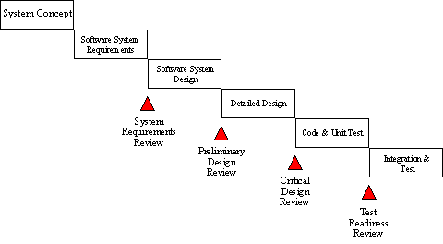

The major and elementary phase is discussed as below:

1. Requirements, Determination And Specification
2. Feasibility Analysis
3. Analysis Phase(Final Specification And Hardware Study)
4. Design Phase Or System Design
5. System Implementation(Coding)
6. System Evaluation Or System Testing
7. System Modification and Maintenance or System Post-Implementation.

**Feasibility:-**

The feasibility study is used to determine if the project should get the go-ahead. If the project is to proceed, the feasibility study will produce a project plan and budget estimates for the future stages of development.

**Requirement Analysis and Design**:-

Analysis gathers the requirements for the system. This stage includes a detailed study of the business needs of the organization. Options for changing the business process may be considered. Design focuses on high level design like, what programs are needed and how are they going to interact, low-level design (how the individual programs are going to work), interface design (what are the interfaces going to look like) and data design (what data will be required). During these phases, the software's overall structure is defined.

**Implementation**:-

In this phase the designs are translated into code. Computer programs are written using a conventional programming language or an application generator. Programming tools like Compilers, Interpreters, and Debuggers are used to generate the code. Different high level programming languages like C, C++, Pascal, and Java are used for coding.

**Testing**:-

In this phase the system is tested. Normally programs are written as a series of individual modules, these subjects to separate and detailed test.. The system is tested to ensure that interfaces between modules work (integration testing), the system works on the intended platform and with the expected volume of data (volume testing) and that the system does what the user requires (acceptance/beta testing).

**Maintenance**:-

Inevitably the system will need maintenance. Software will definitely undergo change once it is delivered to the customer. There are many reasons for the change. Change could happen because of some unexpected input values into the system. In addition, the changes in the system could directly affect the software operations. The software should be developed to accommodate changes that could happen during the post implementation period.

**SYSTEM DESIGN**

### INTROUCTION TO SYSTM DESIGN

Software design sits at the technical kernel of the software engineering process and is applied regardless of the development paradigm that is used. As in the case of any systematic approach, this software too has undergone the best possible design phase fine tuning all efficiency, performance and accuracy levels. The design phase is a transition from a user oriented document to a document to the programmers or database personnel. System design goes through two phases of development: Logical and Physical Design.

**INPUT DESIGN:-**

The design of input focuses on controlling the amount of input required, controlling the errors, avoiding delay, avoiding extra steps and keeping the process simple. The input is designed in such a way so that it provides security and ease of use with retaining the privacy. Input Design considered the following things:

* What data should be given as input?
* How the data should be arranged or coded?
* The dialog to guide the operating personnel in providing input.
* Methods for preparing input validations and steps to follow when error occur.

**OUTPUT DESIGN:-**

A quality output is one, which meets the requirements of the end user and presents the information clearly. In output design it is determined how the information is to be displaced for immediate need and also the hard copy output. It is the most important and direct source information to the user. Efficient and intelligent output design improves the system’s relationship to help user decision-making.

Designing computer output should proceed in an organized, well thought out manner; the right output must be developed while ensuring that each output element is designed so that people will find the system can use easily and effectively. When analysis designs computer output, they should.

* Identify the specific output that is needed to meet the requirements.
* Select methods for presenting information.
* Create document, report, or other formats that contain information produced by the system.

**SNAPSHOTS**

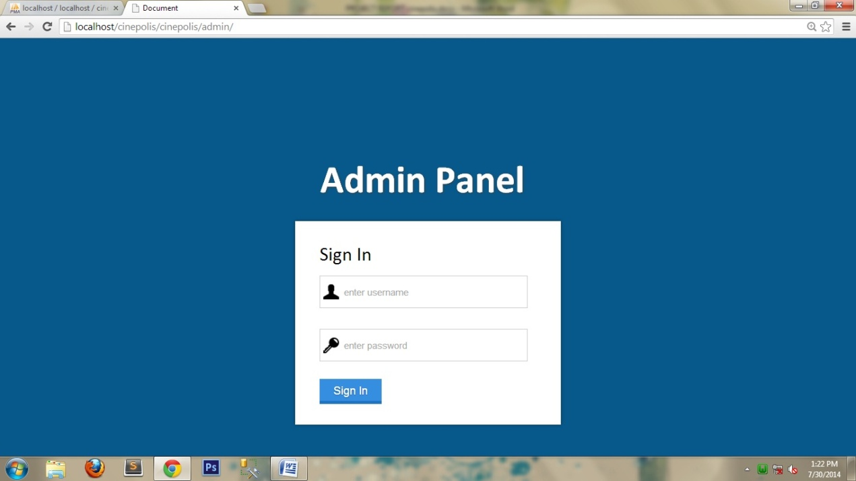

**Admin Panel**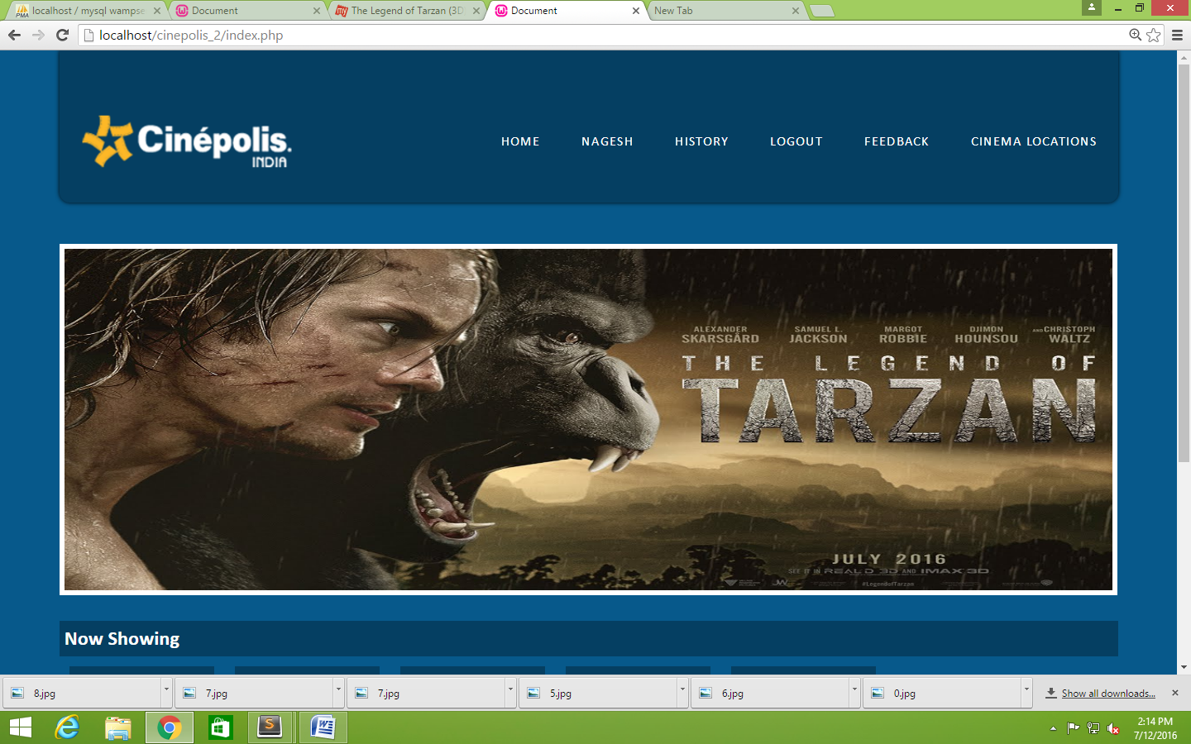

**Home Page**

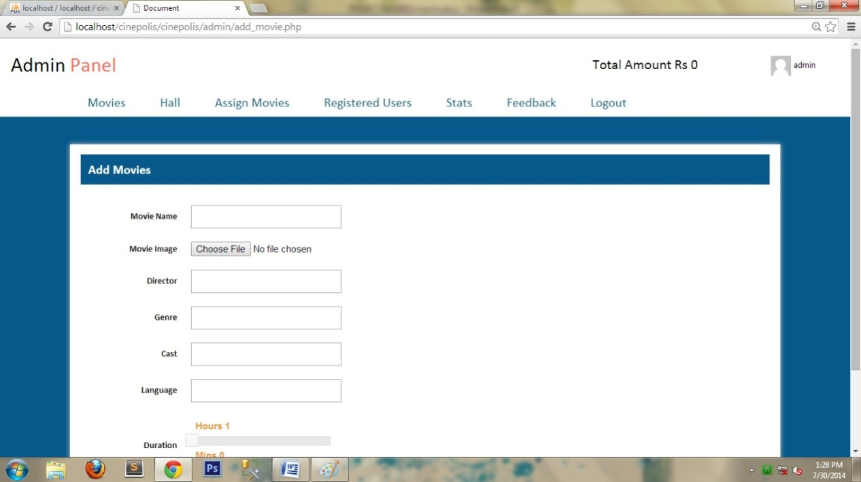

**Add Movies**

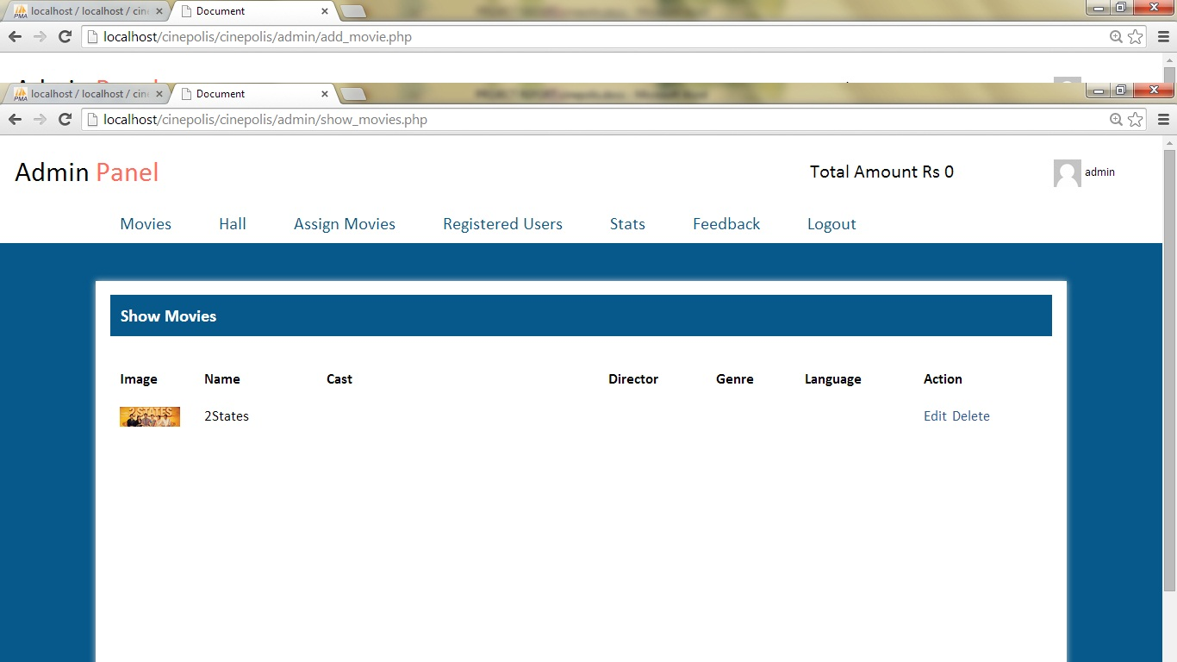

**Show Movies**

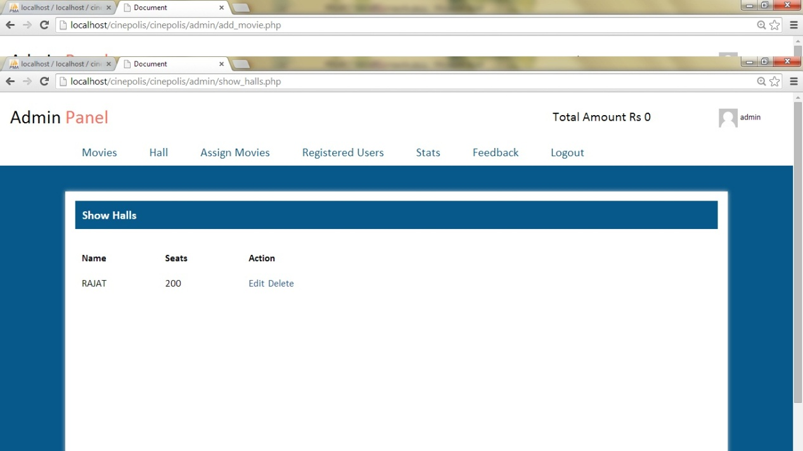

**Show Halls**

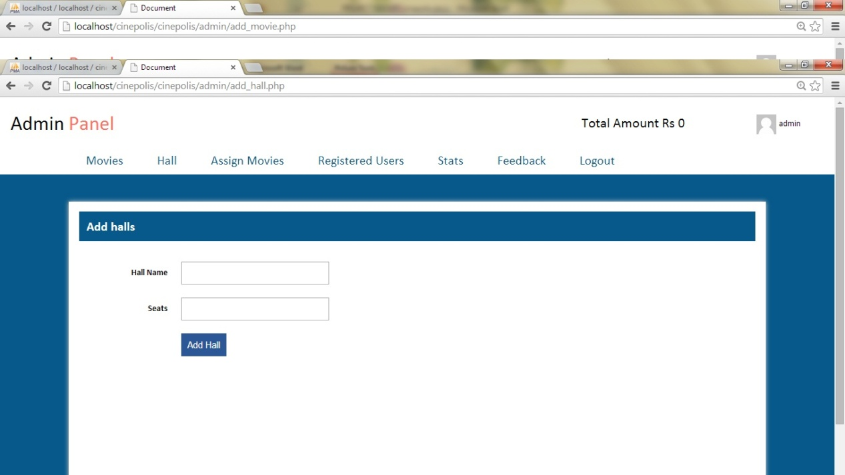

**Add Panel**

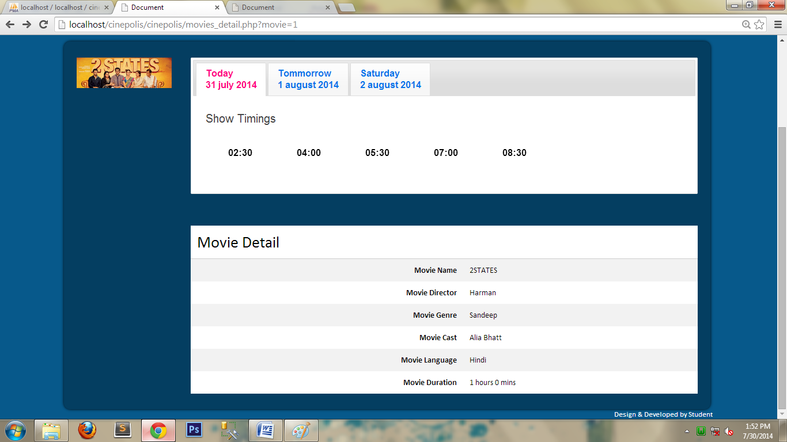**Show Timings**

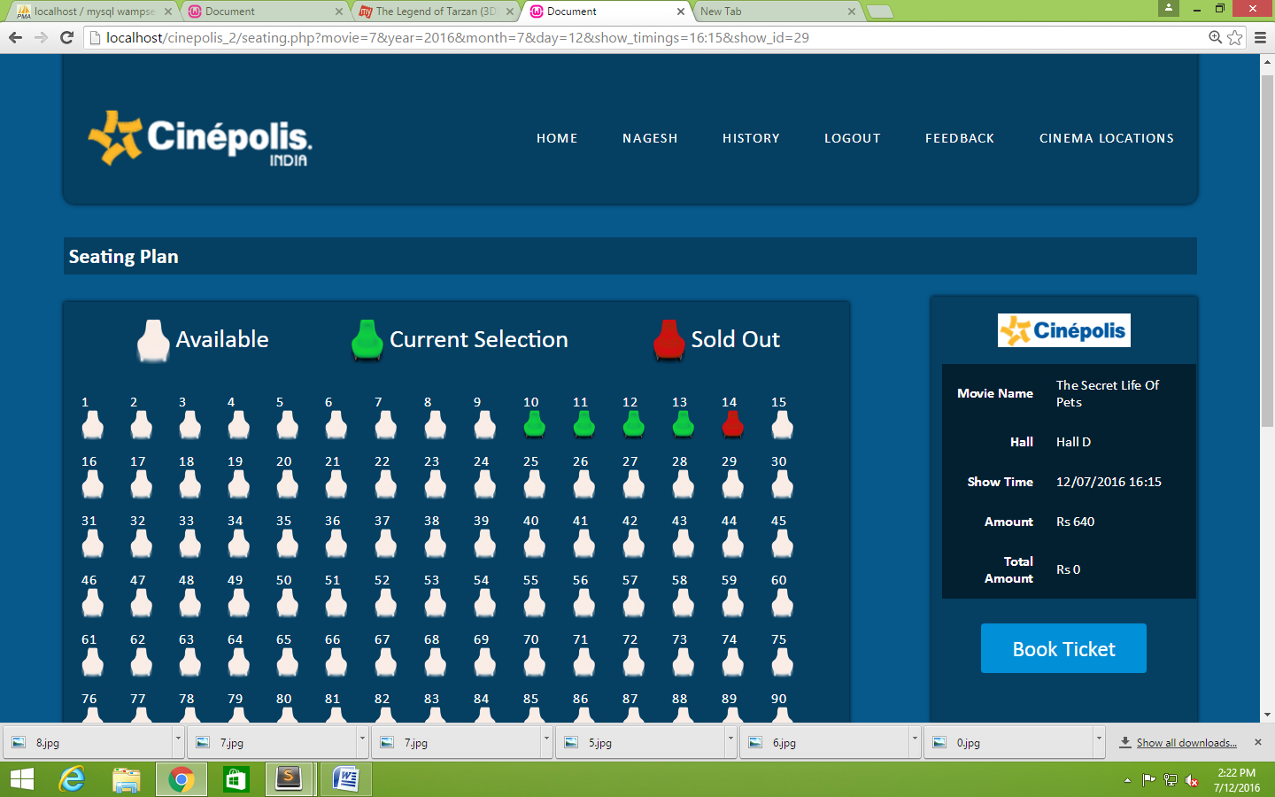

**Sitting Plan**

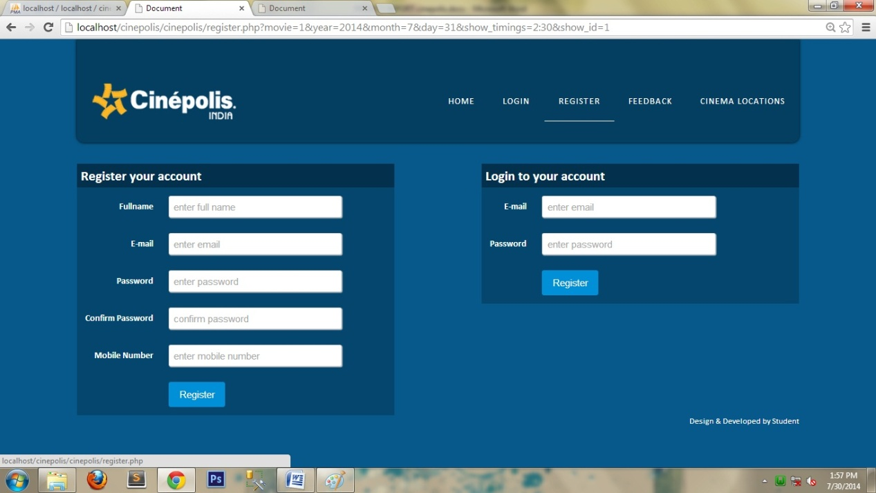

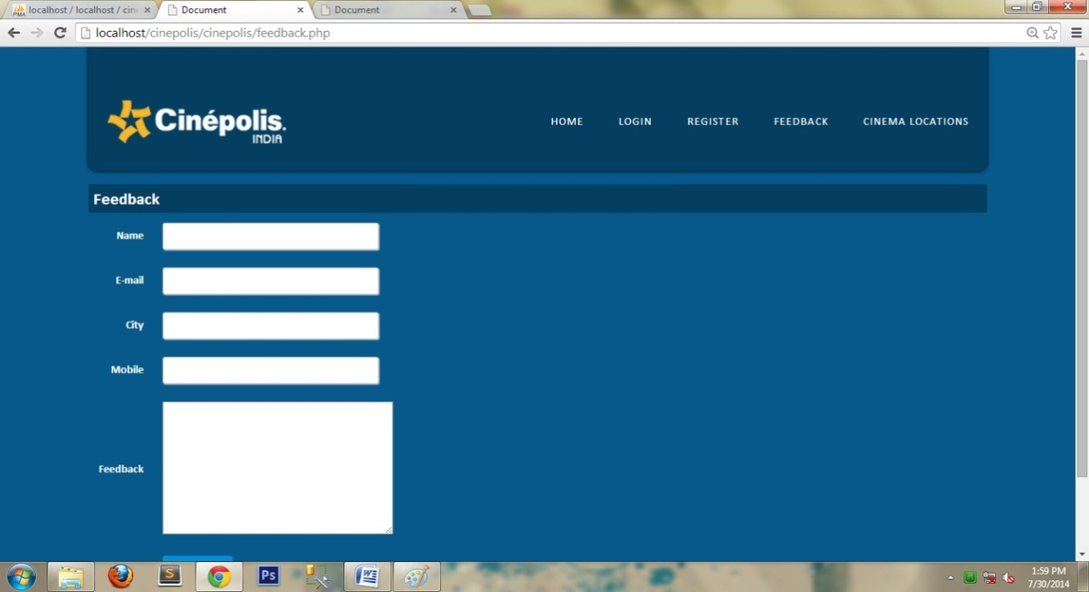**Login & Sign Up**

**FEEDBACK**

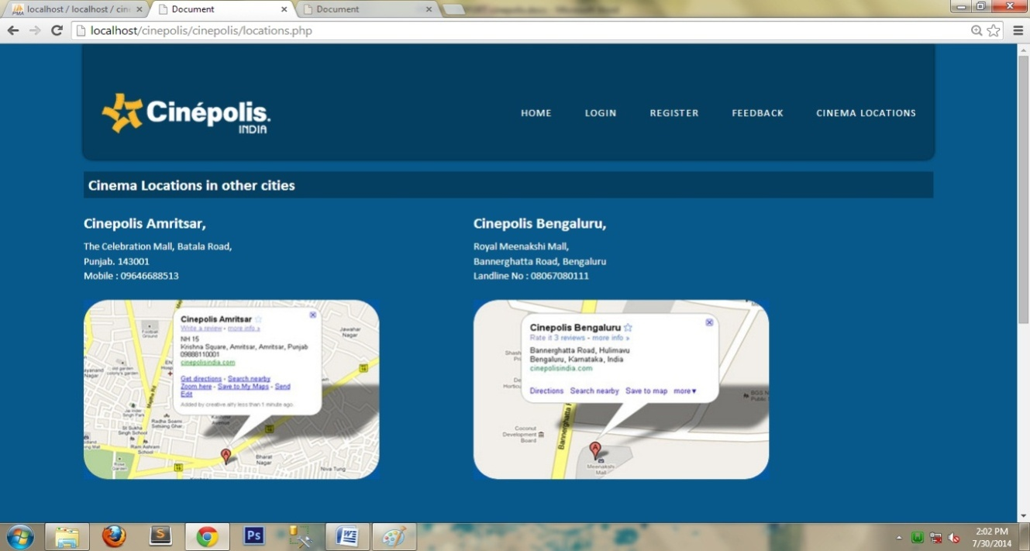

**CINEMA LOCATIONS**

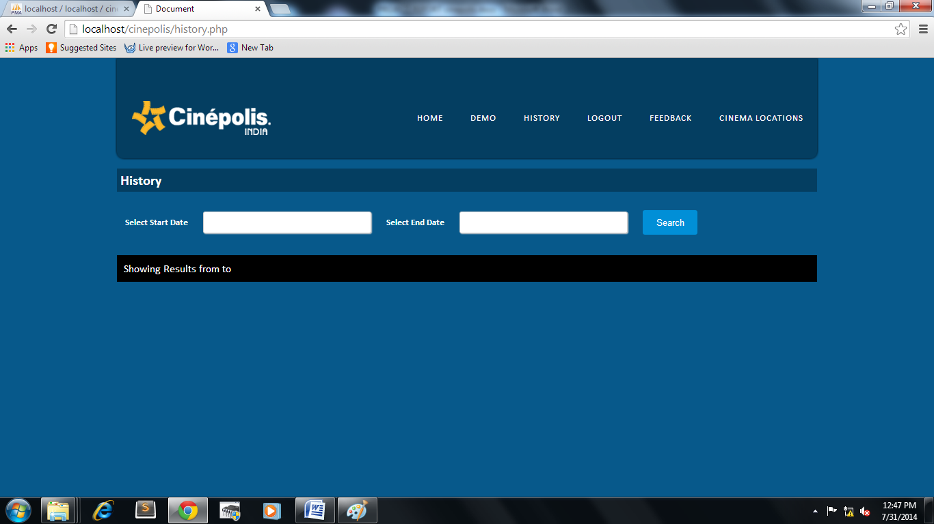

**HISTORY**

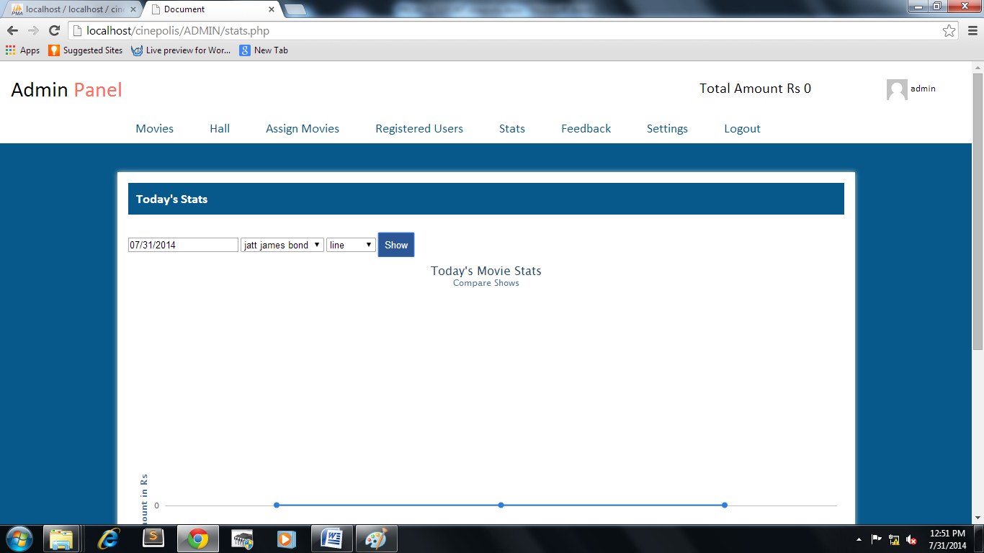

**STATS**

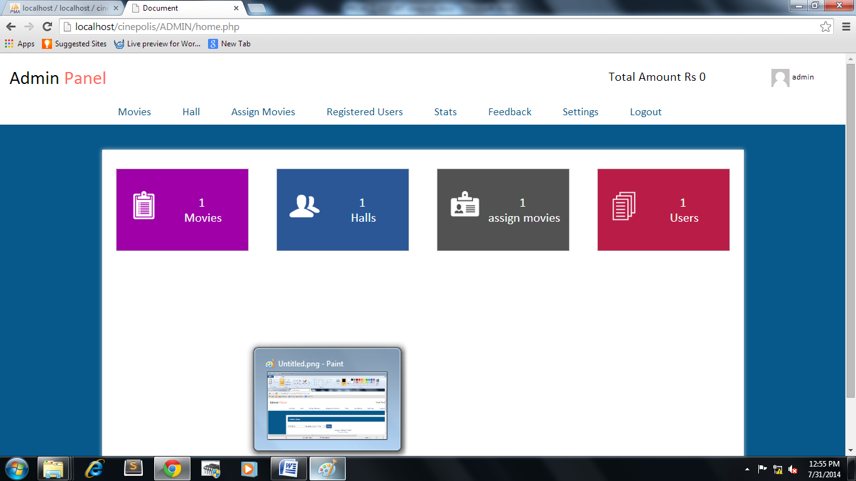

**Admin Panel**

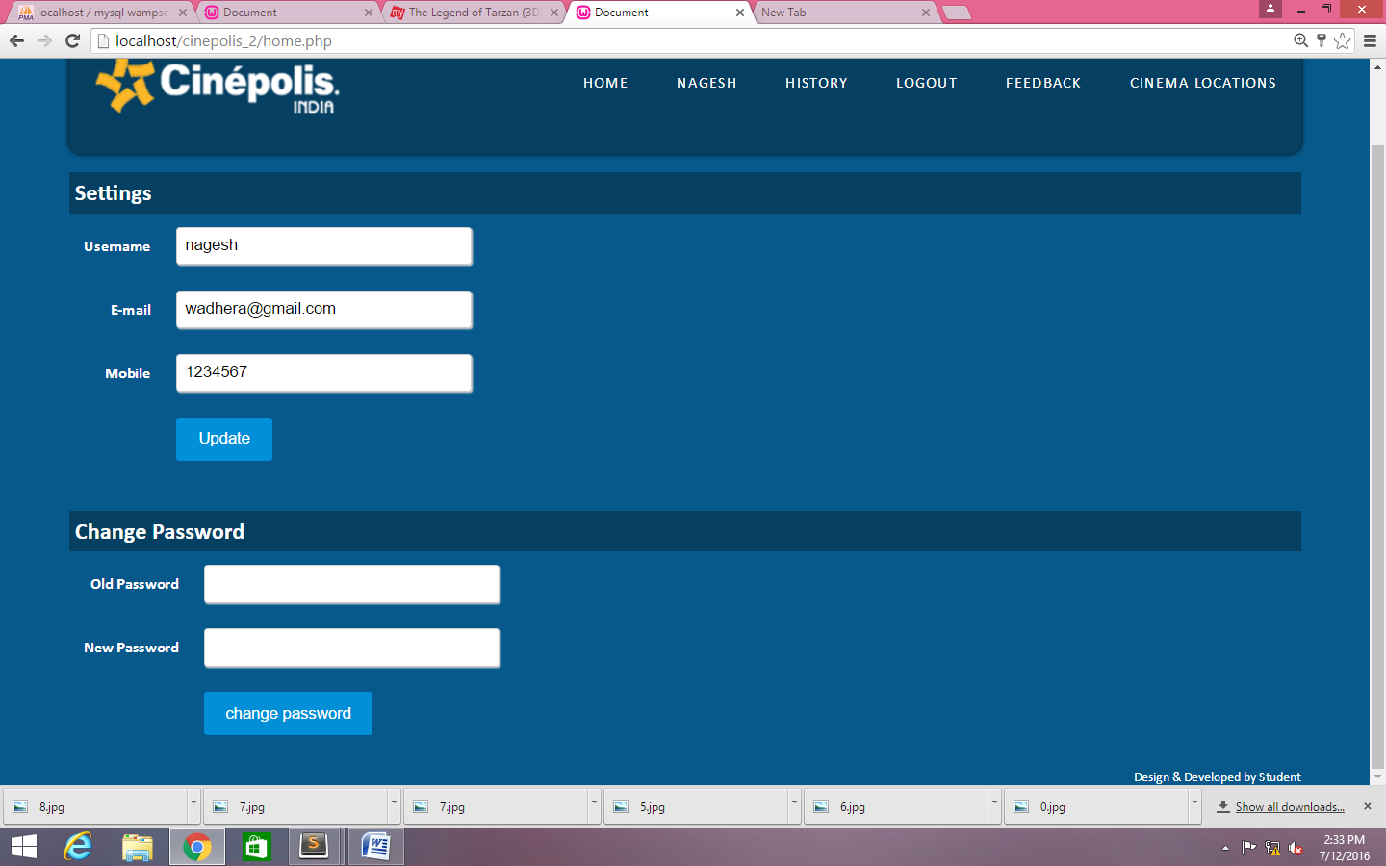

**User Settings and Change Password**

**TABLES**

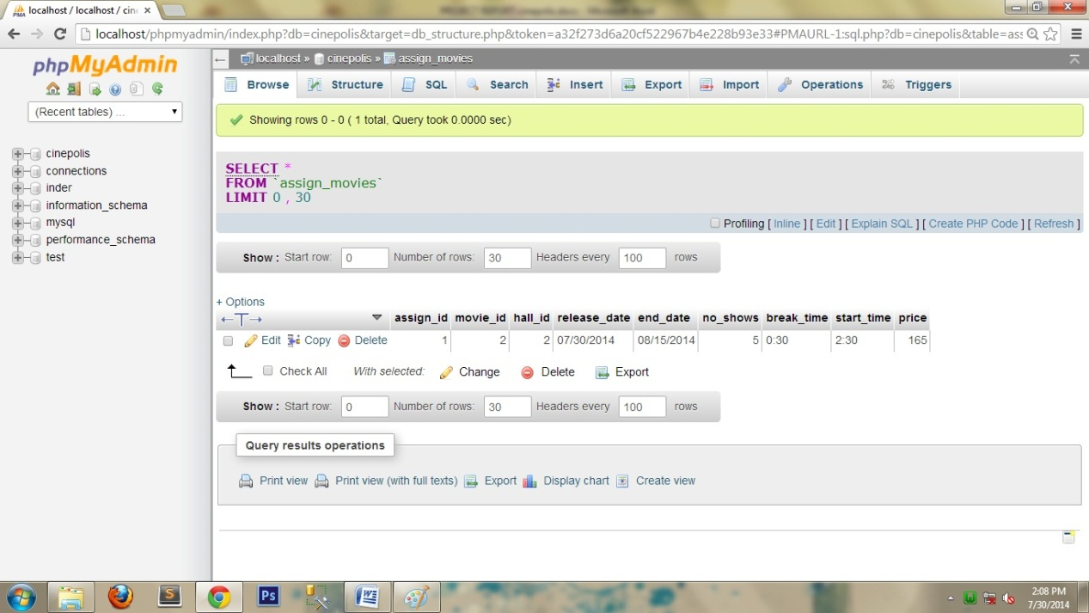

**Home**

|  |  |
| --- | --- |
| **Table** | **Action** |
| admin |  |
| assign_movies |  |
| booking |  |
| feedback |  |
| halls |  |
| movies |  |
| show_timings |  |
| tickets |  |
| users |  |

|  |  |  |  |  |  |  |  |  |
| --- | --- | --- | --- | --- | --- | --- | --- | --- |
| **#** | **name** | **type** | **collation** | **attributes** | **null** | **default** | **extra** | **action** |
| 1 | feedback_id | int(11) |  |  | no | none | auto increament | primary |
| 2 | name | varchar(255) | latin1_swedish_ci |  | no | none |  |  |
| 3 | email | varchar(255) | latin1_swedish_ci |  | no | none |  |  |
| 4 | phone | varchar(255) | latin1_swedish_ci |  | no | none |  |  |
| 5 | msg | text | latin1_swedish_ci |  | no | none |  |  |

**Feedback**

|  |  |  |  |  |  |  |  |  |
| --- | --- | --- | --- | --- | --- | --- | --- | --- |
| **#** | **name** | **type** | **collation** | **attributes** | **null** | **default** | **extra** | **action** |
| 1 | movie_id | int(11) |  |  | no | none | auto increament | primary |
| 2 | movie_name | varchar(300) | latin1_swedish_ci |  | no | none |  |  |
| 3 | movie_director | varchar(300) | latin1_swedish_ci |  | no | none |  |  |
| 4 | movie_genre | varchar(300) | latin1_swedish_ci |  | no | none |  |  |
| 5 | movie_cast | varchar(300) | latin1_swedish_ci |  | no | none |  |  |
| 6 | movie_languages | varchar(300) | latin1_swedish_ci |  | no | none |  |  |
| 7 | movie_images | varchar(300) | latin1_swedish_ci |  | no | none |  |  |
| 8 | movie_hours | int(11) |  |  | no | none |  |  |
| 9 | movie_mins | int(11) |  |  | no | none |  |  |

**Movies**

|  |  |  |  |  |  |  |  |  |
| --- | --- | --- | --- | --- | --- | --- | --- | --- |
| **#** | **name** | **type** | **collation** | **attributes** | **null** | **default** | **extra** | **action** |
| 1 | show_id | int(11) |  |  | no | none | auto increament | primary |
| 2 | assign_id | int(11) |  |  | no | none |  |  |
| 3 | show timings | varchar(255) | latin1_swedish_ci |  | no | none |  |  |

**Show_timings**

|  |  |  |  |  |  |  |  |  |
| --- | --- | --- | --- | --- | --- | --- | --- | --- |
| **#** | **name** | **type** | **collation** | **attributes** | **null** | **default** | **extra** | **action** |
| 1 | user_id | int(11) |  |  | no | none | auto increament | primary |
| 2 | user_name | varchar(200) | latin1_swedish_ci |  | no | none |  |  |
| 3 | user_email | varchar(200) | latin1_swedish_ci |  | no | none |  |  |
| 4 | user_password | varchar(200) | latin1_swedish_ci |  | no | none |  |  |
| 5 | user_mobile | varchar(200) | latin1_swedish_ci |  | no | none |  |  |

**Users**

|  |  |  |  |  |  |  |  |  |
| --- | --- | --- | --- | --- | --- | --- | --- | --- |
| **#** | **name** | **type** | **collation** | **attributes** | **null** | **default** | **extra** | **action** |
| 1 | booking_id | int(11) |  |  | no | none | auto increament | primary |
| 2 | user_id | int(11) | latin1_swedish_ci |  | no | none |  |  |
| 3 | total | varchar(255) |  |  | no | none |  |  |
| 4 | assign_id | int(11) |  |  | no | none |  |  |
| 5 | show_id | int(11) |  |  | no | none |  |  |
| 6 | day | varchar(255) | latin1_swedish_ci |  | no | none |  |  |

**Booking**

|  |  |  |  |  |  |  |  |  |
| --- | --- | --- | --- | --- | --- | --- | --- | --- |
| **#** | **name** | **type** | **collation** | **attributes** | **null** | **default** | **extra** | **action** |
| 1 | hall_id | int(11) |  |  | no | none | auto increament | primary |
| 2 | hall_names | varchar(255) | latin1_swedish_ci |  | no | none |  |  |
| 3 | hall_seats | int(11) |  |  | no | none |  |  |

**Halls**

**CONCLUSION**

Using a web hosting service can be very restrictive as much of this document shows. A large

percentage of problems occurring during development were caused by the web hosting

service not supporting a technology or settings under the control of the web hosting company.

The only way of guaranteeing that a program can make use of any functionality that a system

will require not to use a web hosting service, but instead set up a web server dedicated to

running any programmes written. This allows program developers to install or allow use of

any functionality they require for their program to work. Another advantage of not using a

web hosting service is the program could have been made more portable if it was originally

written on a dedicated server. However, running your own web server for such a site as this

requires a lot of knowledge on keeping a server freely available to the public secure.

This has prompted my to put more effort in to learn how to setup and administer a web server

for any future work to ensure that programs are not compromised by what the web hosting

company do and do not offer.

The project has introduced me to a number of aspects for programming for the Internet

including: how to write program so that it is as secure as possible. I found the research about

the security issues and how to protect a website very interesting. My only regrets about the

security of the site was not being able to use SSL and I wish I had researched more security

issues before starting coding as this would have saved a lot of time.

**SCOPE AND FUTURE REFERENCES OF THIS PROJECT**

This ticket booking system for PVR cinemas is a slice of real time management system that can be practically implemented. However there are certain assumptions and certain limitations that could be overcome and various new application could be added like:

* This management system can be applied to each and every source and destination.
* Mode of payment can be modernized Cancellation and refund can be implemented
* At the time of reservation customer could choose from different types of seats. Pricing can be made dynamic

The advantages and disadvantages of this site are much same as those of real life. However an effort to make this site is usually far less than expended for the real life system. The most difficult problem in specifying a virtual machine which can easily coexist with the desired target system. In some respects, this approach makes sense for making people buying tickets on web. The identification of clear cut interfaces is a standard structured programming technique, which reduces software maintenance cost now when site is easily available to a user through website , it is easy and convenient for them to be in touch with their customers. It gives further opportunity to the coming users to enhance the IT Technologies**.**

**BIBLIOGRAPHY**

To bring the system to verge of completion the following books have been referred:

* PHP 5.3 By Matt Doyle
* PHP for Dummies By Janet Valade
* Search engine and websites are also used like:
* [www.cinepolis.com](http://www.cinepolis.com)
* [www.w3schools.com](http://www.w3schools.com)
* [www.google.com](http://www.google.com)